

From the Hillman Car Club of South Australia
Welcome to the
17th National Hillman Rally
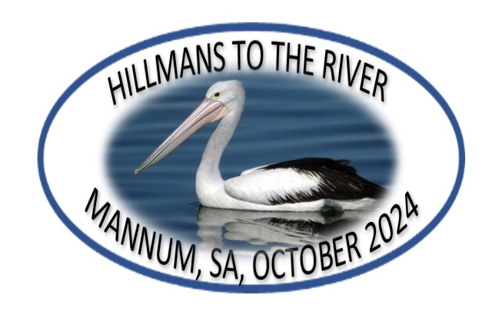
Mannum, South Australia
Friday 18 Oct to Tuesday 22 Oct 2024

WELCOME TO MANNUM
This is the 17th National Hillman Rally, a testament to the friendships and cooperation of Hillman and Rootes Group Clubs over many years.
We hope you enjoy the relaxed river atmosphere of the oldest riverboat town on the Murray River. There is a lot of history in Mannum and we have tried to leave some spare time between events so that you can have a look around. In the rally pack, there is a double pass for the museum which is valid for the duration of the rally. The museum is just across the road from the Motel and Caravan Park and is well worth a visit.

THANKS TO OUR SUPPORTERS

HILLMAN CAR CLUB
OF SOUTH AUSTRALIA INC.
www.sa.hillman.org.au


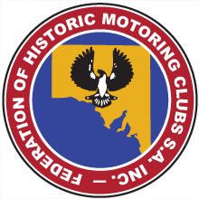





Organising Committee
Steve Freeman 0401 603 596
Keith Parkinson 0421 124 479
Berk Foulds 0409 003 008
Lyn Hunter 0427 437 437
Linda Payne 0403 770 548
Tom Olthoff 0419 828 963
Jeffery Ferry 0422 335 408
Barry Guy 0427 703 527
Barry Hall 0428 103 400
Emergency Contacts
Ring 000 in an emergency, first
Steve Freeman 0401 603 596, second
Breakdown Services
If you are unfortunate enough to break down, in the first instance please call your Rally Co-ordinator Steve Freeman on 0401 603 596.
Mechanical and Tyre repairs and services are TK Tyres and Mechanical, Mannum 8569 2625, see sponsor list.
General Information
General and essential information is included in your Rally Bag.
Medical
Mannum District Hospital is your 24 hour Emergency Medical service. They are located at Parker Street Mannum and can be contacted on Phone (08) 8569 0200

WHO IS COMING TO THE RALLY
Rally
No. | Name | Surname |  | Mob | Vehicle
1 | Geordie & Christine | Jack | NSW | 0475 517 480 | tba
2 | Peter & Lorraine | Wilson | VIC | 0428 724 572 | 1956 Hillman Minx
3 | Marty & Lynne | Sutherland | VIC | 0406 741 235 | 1966 Superminx Mk3
4 | Lenore Newman & Jim | Wilson | NSW | 0412 929 568 | 1957 Hillman Minx S1
5 | Peter Flavell & Ross | Urquhart | VIC | 0427 368 109 | 1962 Hillman Minx ADL
6 | Dave | Watson | SA | 0408 087 171 | 1968 Commer CC15
7 | Jennifer & Neil | Yeomans | VIC | 0429 295 774 | 1962 Superminx Estate
8 | Allan & Jan | Walter | VIC | 0414 505 892 | Hillman Imp GT
9 | Paul & Mae | Johnson | NSW | 0402 628 242 | Hillman Gazelle
10 | Max & Val | Maher | NSW | 0409 903 787 | 1960 Hillman Minx 3A
11 | Darryl, Veronica, Terry, Phil | Ferguson | WA | 0478 603 424 | Hillman Minx 3B
12 | Steve & Lesley | Freeman | SA | 0401 603 596 | 1954 Hillman Husky Mk1
13 | Barry Guy & Linda | Payne | SA | 0403 770 548 | 1955 Commer Superpoise
14 | Lindsay | Marskell | NSW | 0409 830 623 | 1962 Superminx Mk2
15 | Barry | Hall | SA | 0428 103 400 | 1975 Hillman Avenger
16 | Jeffrey | Ferry | SA | 0466 790 226 | 1965 Hillman Imp
17 | Des & Marg | Whitburn | SA |  | 1969 VF Chrysler Valiant
19 | Shiran & Imara | Fernando | VIC | 0413 081 344 | Hillman Hunter HC
20 | Ros & Robert | Brown | SA | 0412 202 985 | 1955 Hillman Minx Mk8
21 | Berk & Barb | Foulds | SA | 0409 003 008 | 1965 Hillman Minx
22 | Lyn & Sandy Knight | Hunter | SA | 0427 437 437 | modern
23 | Keith & Jann | Parkinson | SA | 0421 124 479 | 1972 Hillman Hunter
24 | Tom & Maureen | Olthoff | SA | 0419 828 963 | 1963 Hillman Imp
32 | Leah Ferguson & Noel | Lane | WA | 0418 955 749 | 1966 Hillman Gazelle
28 | Peter & Denise | Jensen | VIC | 0433 443 827 | 1957 Hillman Husky
29 | Terrence | Chin | WA | 0415 419 866 | 1963 Superminx
30 | Brian | Vogt | SA | 7122 1178 | 1966 Hillman Gazelle
31 | David & Ruth | McInroy | NSW | 0400 122 303 | 1960 Hillman Husky
33 | Gary Howard & Colin | McInroy | NSW | 0408 692 673 | 1966 Hillman Gazelle

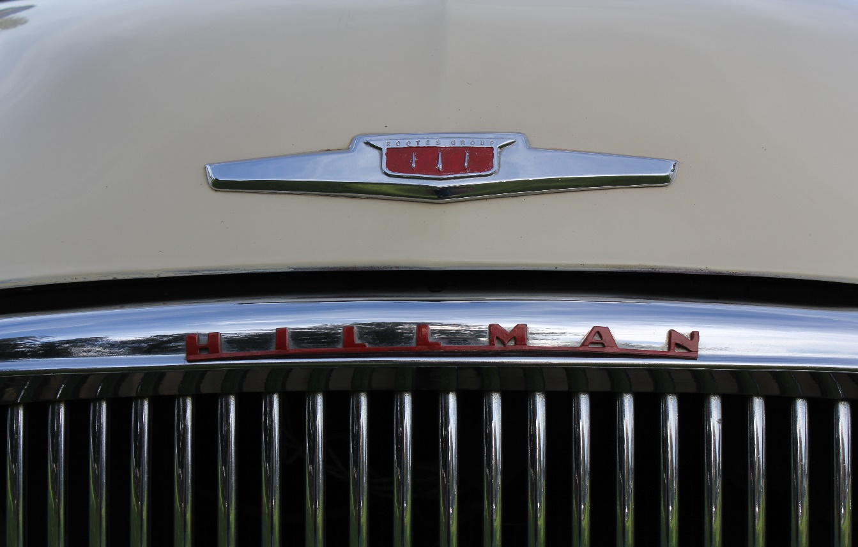
Rally Programme
Friday 18 Oct

2:00 pm Registration and Rally packs at Mannum Motel ‘the Barn’. This is the Rally Headquarters
6:00 pm Welcome casual dinner at the Motel
7:30 pm Ian Doyle and ‘Source to Sea’ talk and film, at the Barn

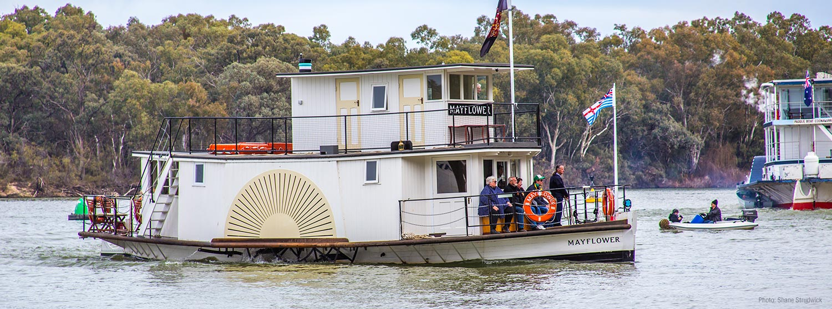

Please remember:
- Update your vehicle log books daily, as required
- Your lanyard / name badge is in the rally pack and gives you access to some activities. There are also vouchers in the rally pack for other activities.
- Please stick the “Shannons” number on the windscreen of your car, so that judges at the “show & shine” know whose car belongs to whom.
- The museum pass in the rally pack is for 2 people for the whole time of the rally. You can visit the museum as often as you like.

Saturday 19 Oct
7:00 – 8:30 Breakfast available at the motel at your expense
9:00 The Barn - briefing
9:00- 9:30 The Barn - vehicles depart at 1 minute intervals for the car show at Mary Anne Reserve, approx. 1 km. Photos of your car will be taken at Mary Anne Reserve
10:00 Mary Anne Reserve – Hillman “Show & Shine”. In the rally pack, there is a $20 voucher for each person for the Randell St Bakery, which is just across the road from the Reserve. Suit yourself whether you want morning tea or lunch or whatever. Be warned, though, the cakes are awesome.
11:00 Mary Anne Reserve - Mayflower 1 hr cruise Group A
1:00 pm Mary Anne Reserve - Mayflower 1 hr cruise Group B
NOTE – the paddle steamer Mayflower leaves from Mary Anne Reserve, so you can leave your car at the “Show & Shine” until you come back from the cruise. There will be someone to watch the cars while you are away.
4:00 pm The Barn – Bus tour departs for Ngaut Ngaut Conservation Park. There will be a welcome by local aboriginal guides, lots of stories, and a bit of a nature walk. It may pay to bring a jumper or coat, just in case it cools down.
Dinner will be at Walkers Flat on the way back to Mannum. Return to Mannum approx. 9:00pm.
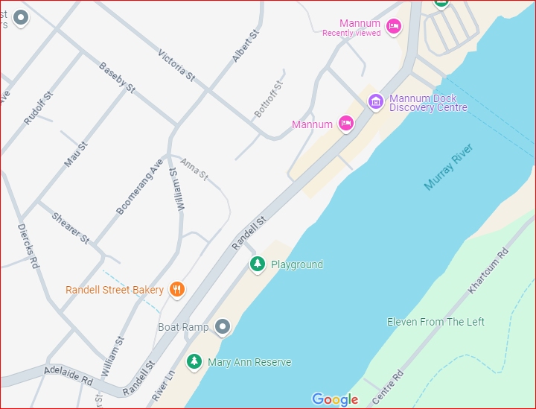
Map of Mannum Motel to Mary Ane Reserve
Sunday 20 Oct

8:00 – 10:00 Breakfast available at the motel at your expense.
9:00 The Barn - briefing
10:30 Depart from the Barn, and drive to Aussie Apricots, Mypolonga, approx. 26 km
11:00 Tour of Aussie Apricots, then drive approx. 500m back to Revolution Motor Museum. Lunch is provided by our hosts, Paul & Kathy. After lunch, have a good look around the museum and vehicle restoration workshop.
2:30 pm approx. Drive to Wood Lane Reserve. Tea and coffee and cold drinks will be provided. Also supplied is a packet of home-made goodies from the Mannum Hospital Auxiliary.
6:30 pm Mannum Motel – rally dinner and presentations in the dining room at the Motel. Dress code for the rally dinner is "Riverboat" i.e. very casual, whatever you would wear on a houseboat holiday, or anything nautical. The bar will be open early.
At the dinner there will be a raffle, all the proceeds of which go to the Mannum Hospital Auxiliary. Tickets will be $5 each, so bring along all your spare cash notes for a worthy cause.

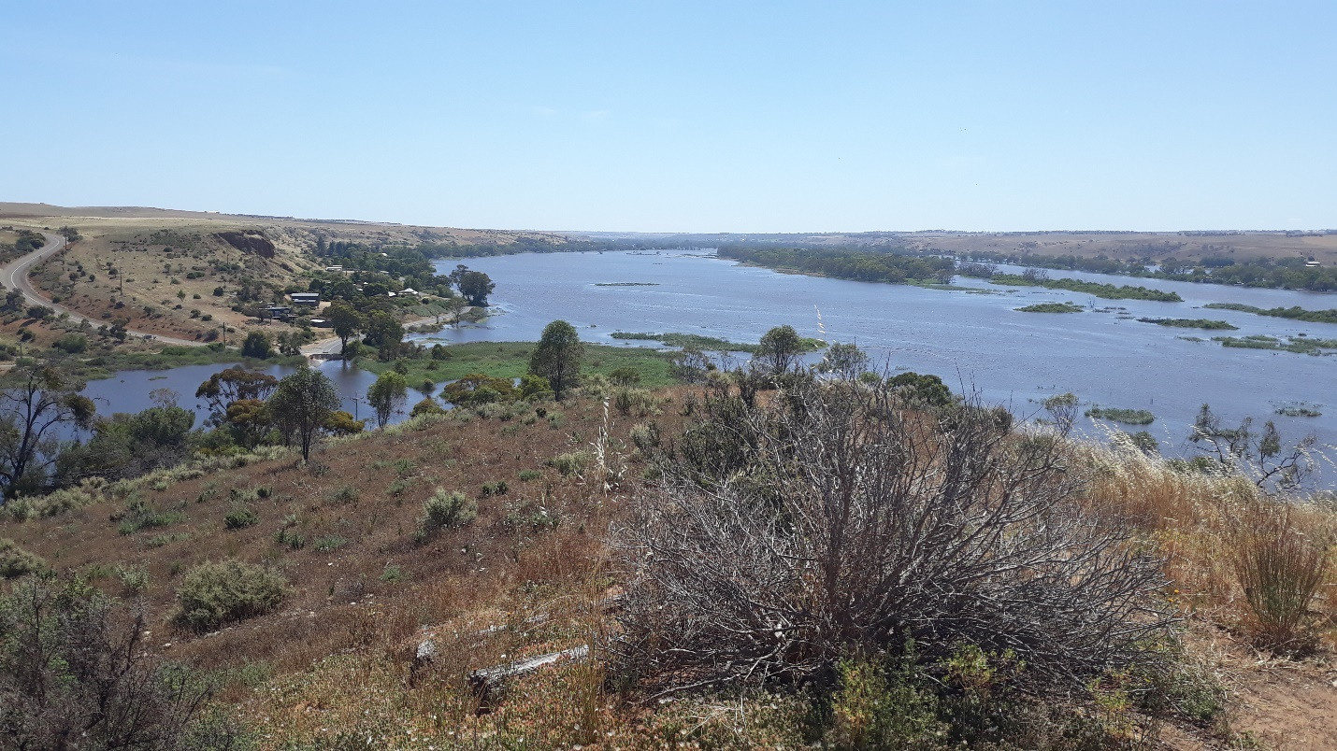

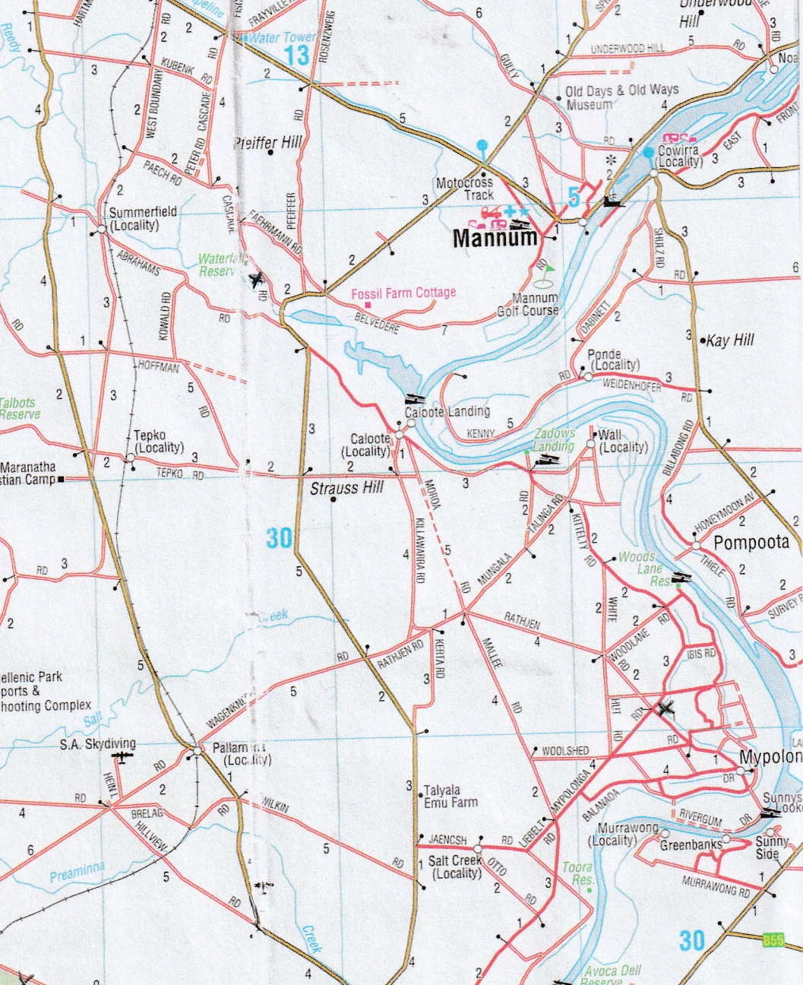
Map of route: - Mannum to Mypolonga
Mypolonga to Wood Lane Reserve
Wood Lane Reserve to Mannum
Monday 21 Oct

8:00 – 10:00 Breakfast available at the motel at your expense.
9:00 The Barn - briefing
9:15 The Barn - Group A drive to Sturt Reserve, Murray Bridge, approx. 32 km.
10:00 At Sturt Reserve. Group A, 1 hour cruise on ‘Four Knots” river boat, including morning tea. Park in any marked parking places as near as possible to the boat.
10:15 The Barn - Group B drive to Sturt Reserve, Murray Bridge, approx. 32 km.
11:00 At Sturt Reserve. Group B, 1 hour cruise on ‘Four Knots” river boat, including morning tea. Park in any marked parking places as near as possible to the boat.
After Cruise Sturt Reserve - drive to Monarto Safari Park. Entry vouchers to Monarto Safari Park are in the rally pack. There is no special tour of the park. Please just look around at your leisure and join one of the Zoo-loop buses which run all day.
A light lunch will be provided in the Zoo café, at any time to suit you. Please show your rally lanyard for payment.
At Monarto Please stay as long as you like until the Park closes at 5:00 pm
When you exit the Park, turn left. At the next intersection, which is the main Mannum Road, turn right back to Mannum. CAUTION – this is a dangerous intersection with fast traffic. Return to Mannum, approx. 33 km.

6:30 pm Pretoria Hotel – walk from the Motel or Caravan Park to the Pretoria for a casual Hillman dinner at the hotel. Meal vouchers will be handed out at the time.

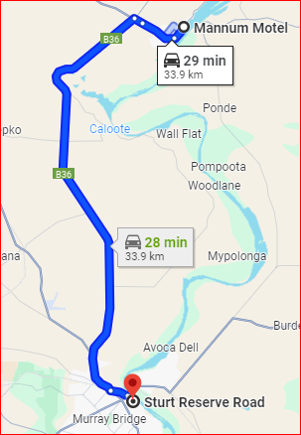
Map of route to Sturt Reserve, Murray Bridge

Mannum Road
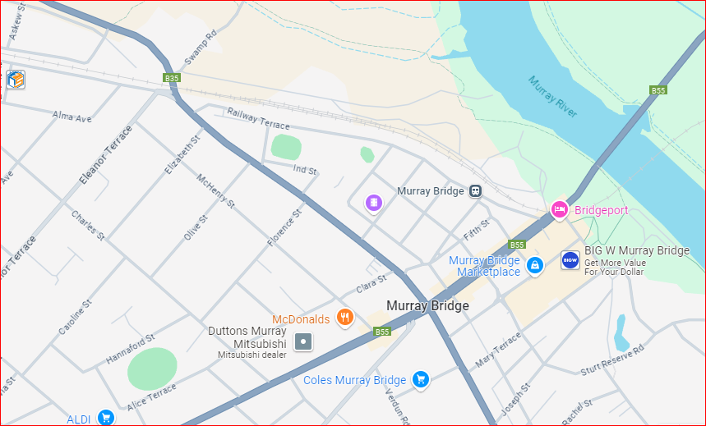
Stuart Reserve
Map of Murray Bridge
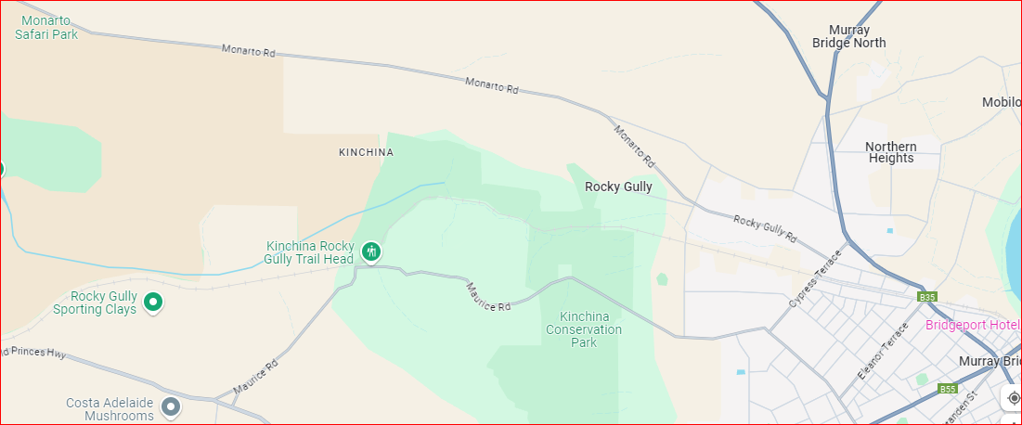
Map of Sturt Reserve to Monarto Safari Park

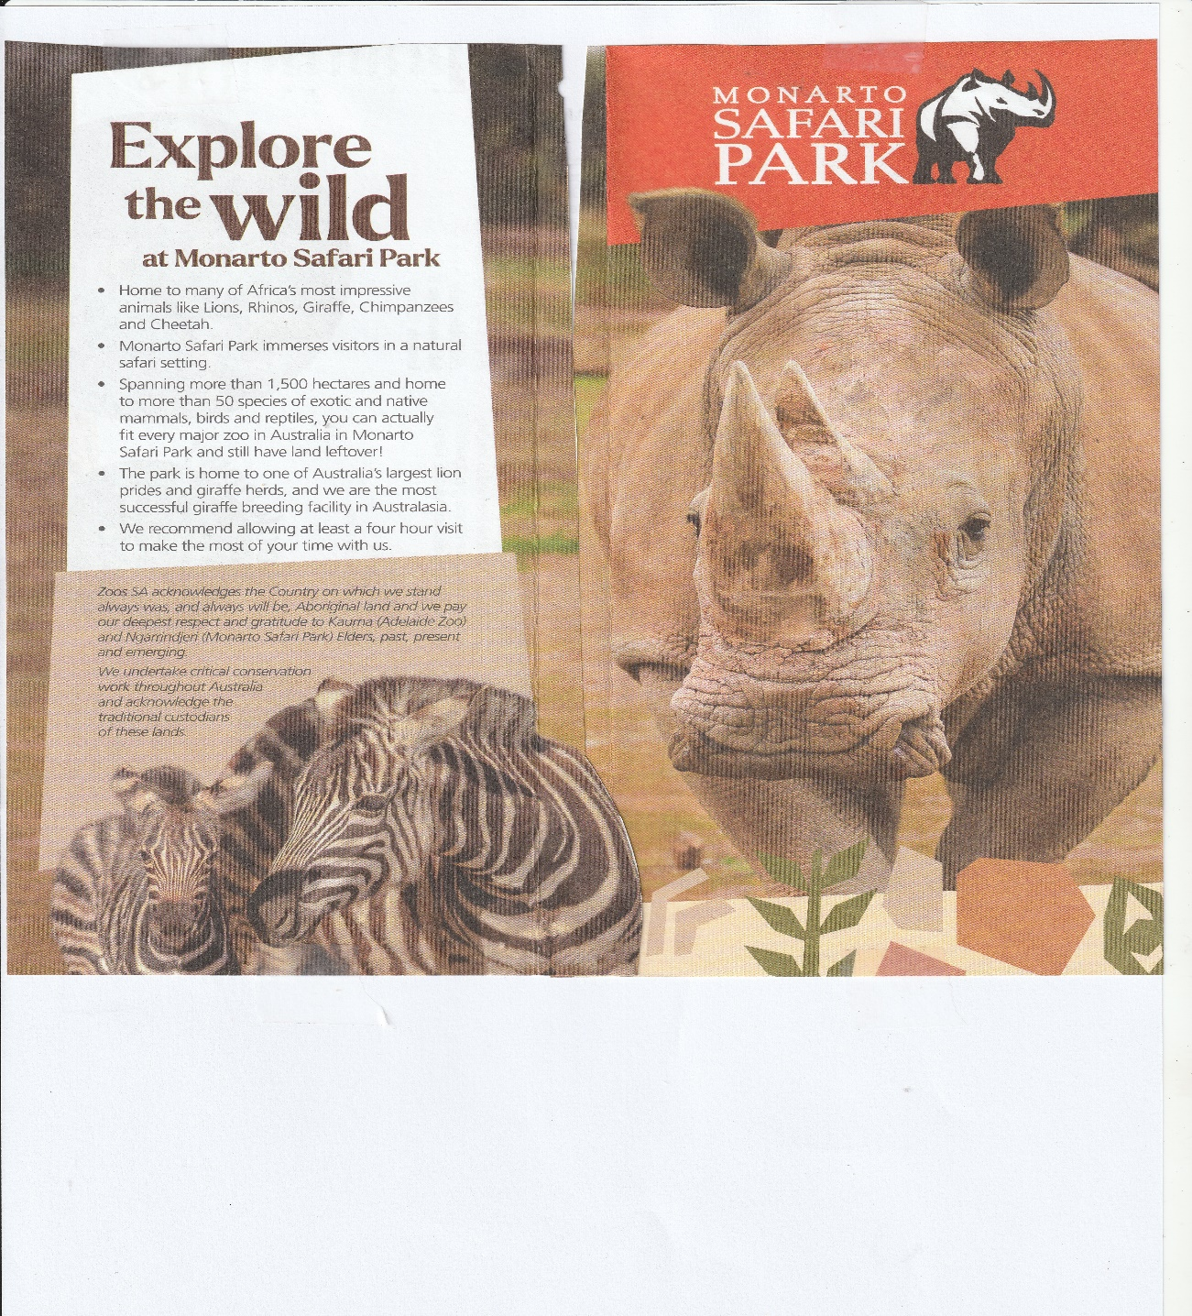

Tuesday 22 Oct
8:00 – 10:00 Breakfast available at the motel at your expense.
Farewell to our fellow Hillman enthusiasts, as you leave. If anyone is staying a bit longer, the museum pass is still valid today. There is also a collection of brochures in the rally pack for interesting places to visit that we did not have time to include.

THE MANNUM HOSPITAL AUXILIARY
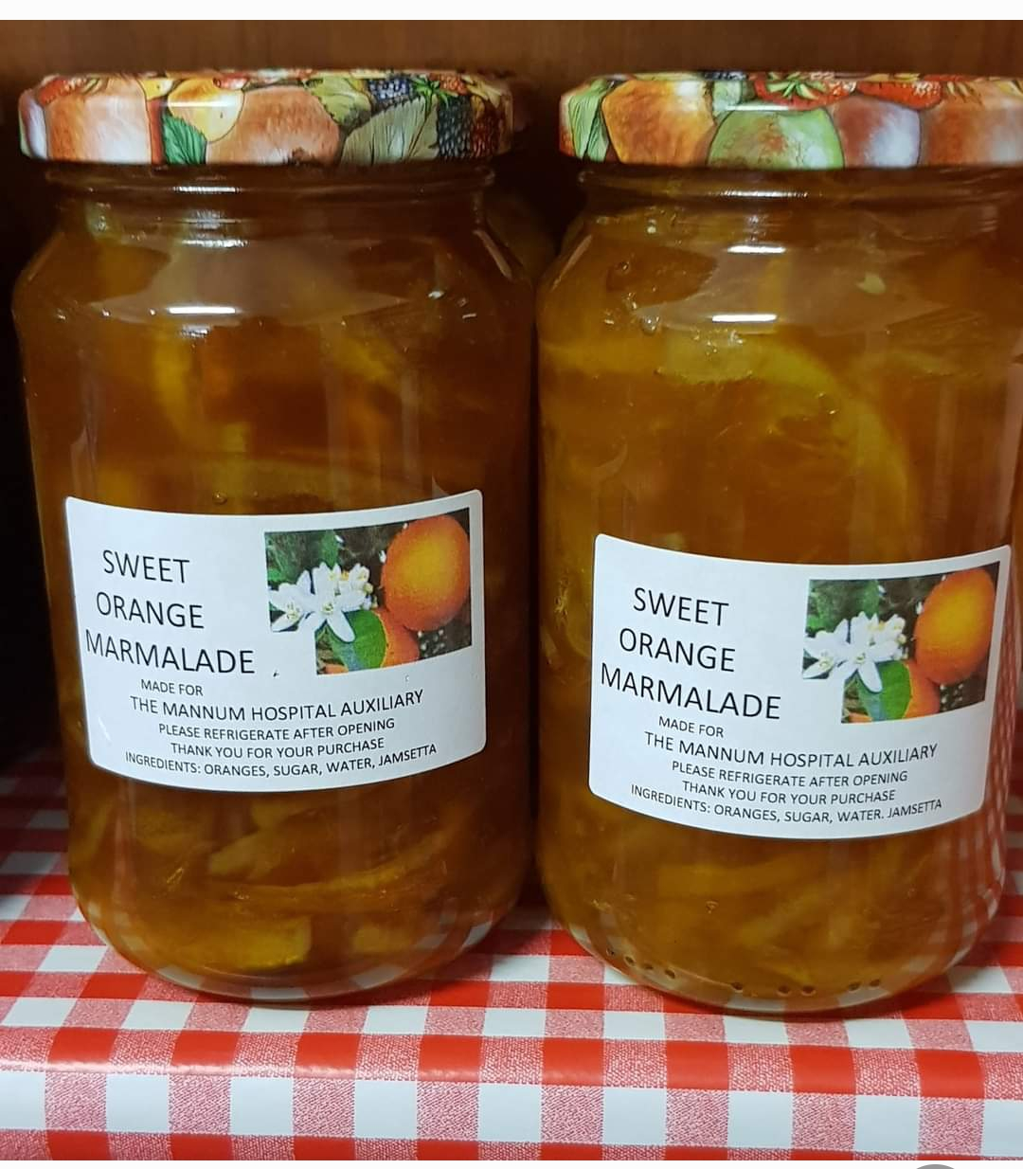
The Mannum Hospital Auxiliary is a group of volunteers who raise funds for the local Mannum Hospital. The National Hillman Rally is proud to support the Auxiliary.
The Mannum Hospital Auxiliary have a home made produce & craft shop in Mannum, but what they are most famous for is their jam. Most items sold in the shop are made by a team of volunteers, so if you are walking up the main street, call in and be tempted. All profits go towards purchasing essential equipment for the Mannum Hospital.
To date the Auxiliary have purchased $660,000.00 of items for the hospital.

Have a safe trip home.

